Email Alert

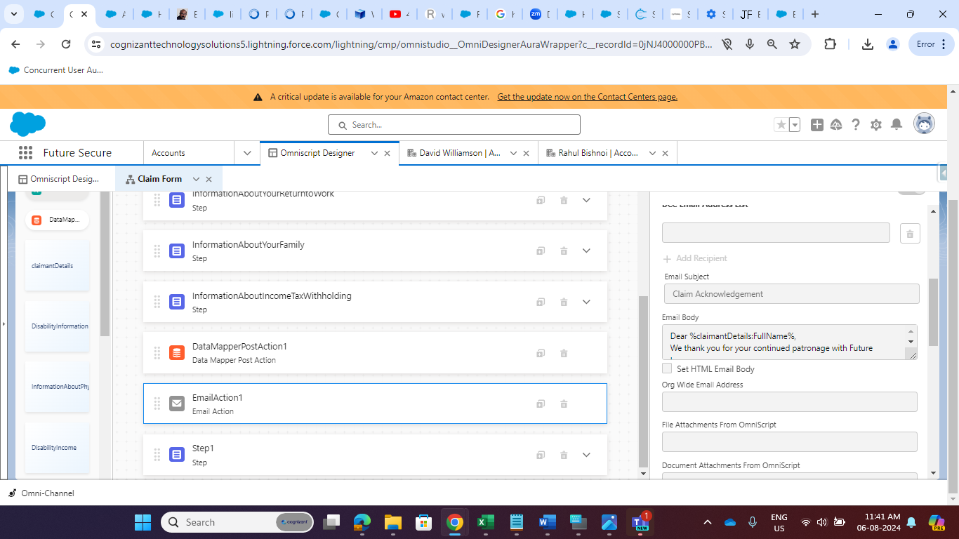

Template

Dear %claimantDetails:FullName%,

We thank you for your continued patronage with Future Insurance.

We acknowledge your long-term disability claim submission %claimantDetails:Claim_Number% for %claimantDetails:Policy_Number%. Our team is currently reviewing the information provided.

Please allow us some time to assess your claim thoroughly.

If additional documentation or medical records are required, we will reach out to you promptly.

In the meantime, please keep any relevant documents ready for our review.

For any urgent matters, please contact our claims helpline at +16018123677.

Thank you for choosing Future Insurance. We appreciate your trust in us.

Sincerely,

Claims Department, Future Insurance.

After that Email is not sending from Salesforce Org So I make Changes in Deliverability(From Setup)

Disable All check box.

1. Activate bounce management.
2. Enforce email privacy settings
3. Enable compliance with standard email security mechanisms
4. Enable Sender ID compliance.

After that we can send mail from this org. to any Gmail account.

Note: Cognizant Email is not Working so I am Finding out the Solutions.

For Template we must select Template Checkbox on.

1. Select Template which is designed.
2. Pass Email Target Object Id(%ContextId%)
3. Pass What ID (%conId%)

